Day 1 introduction to python

**Day 2**

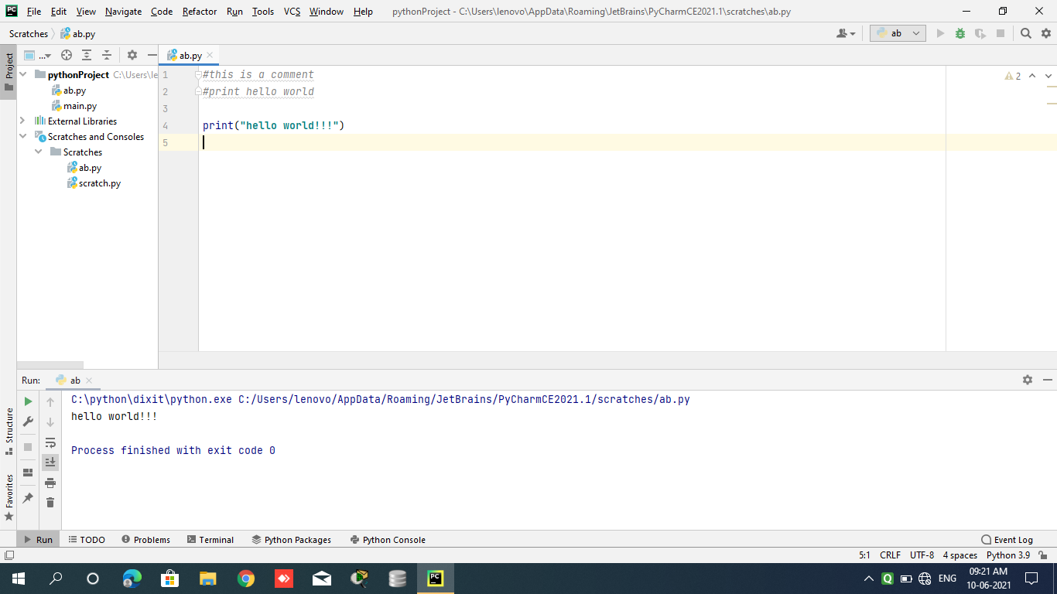

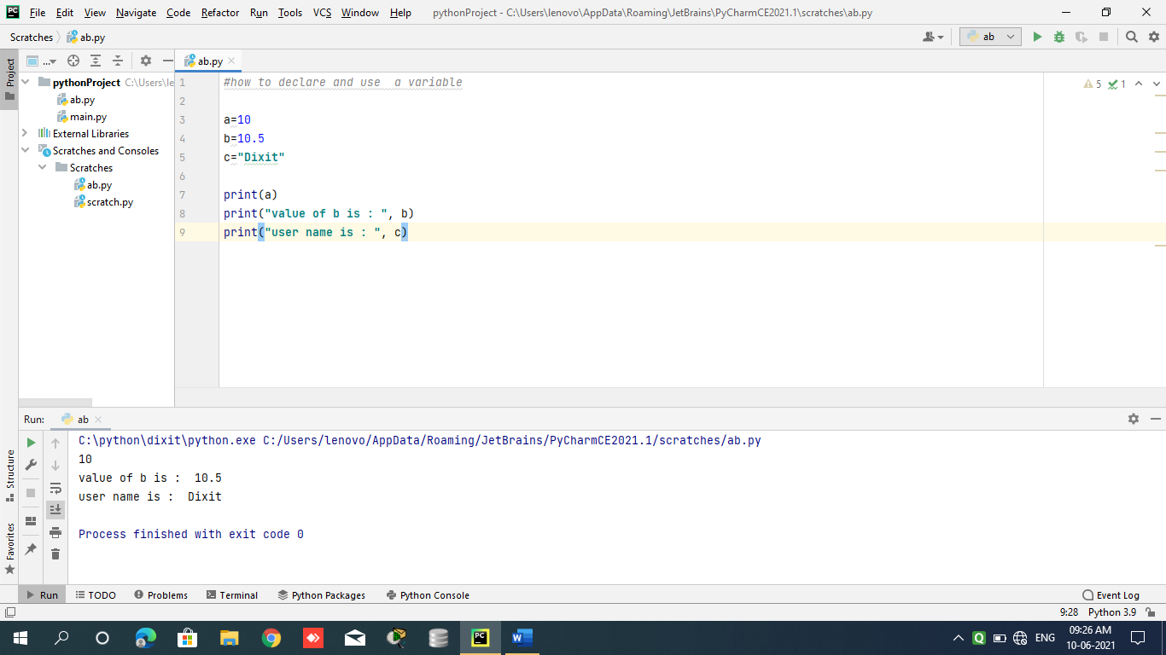

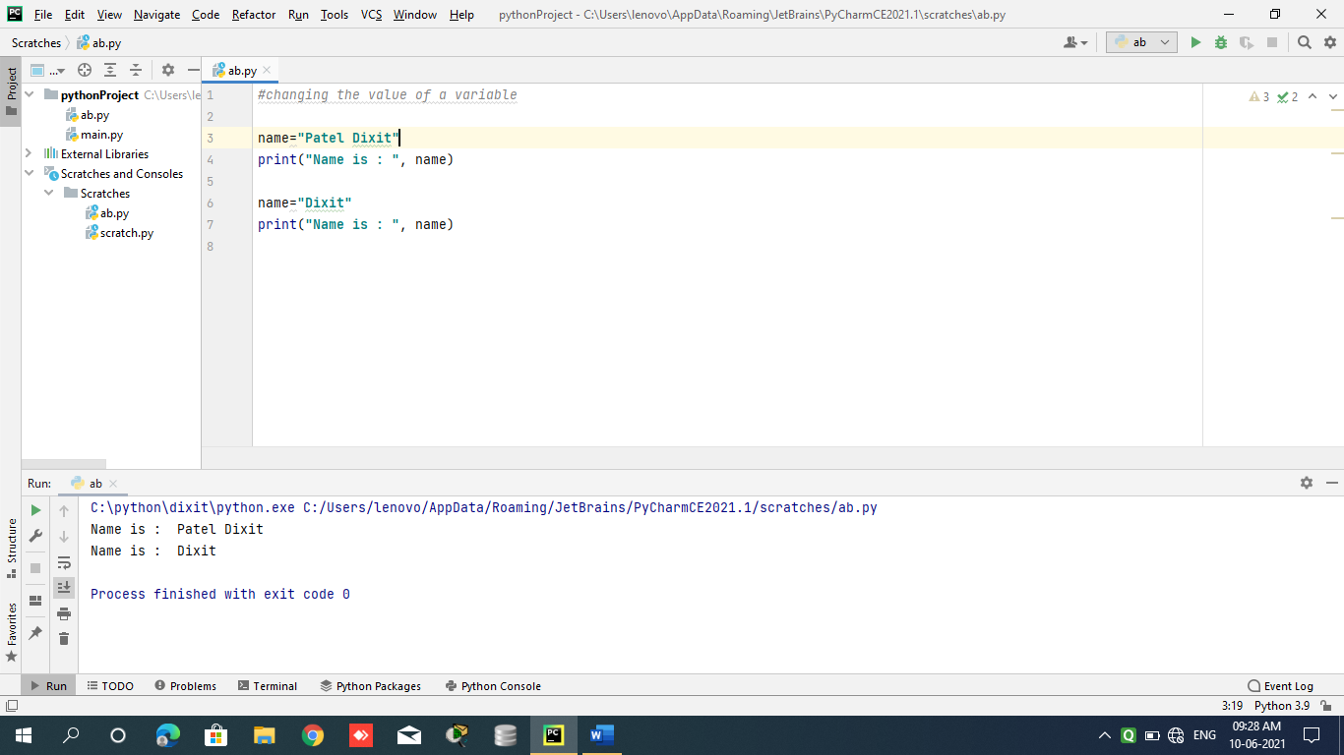

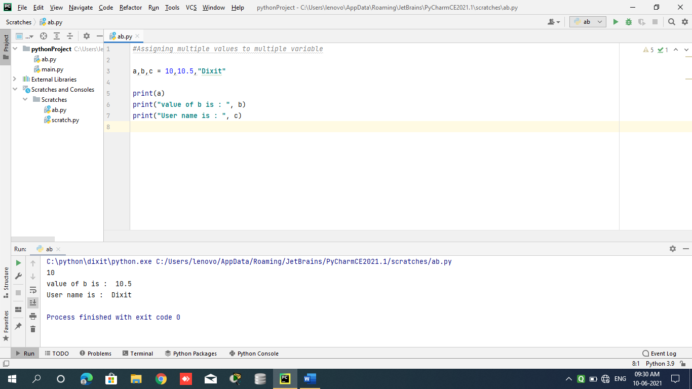

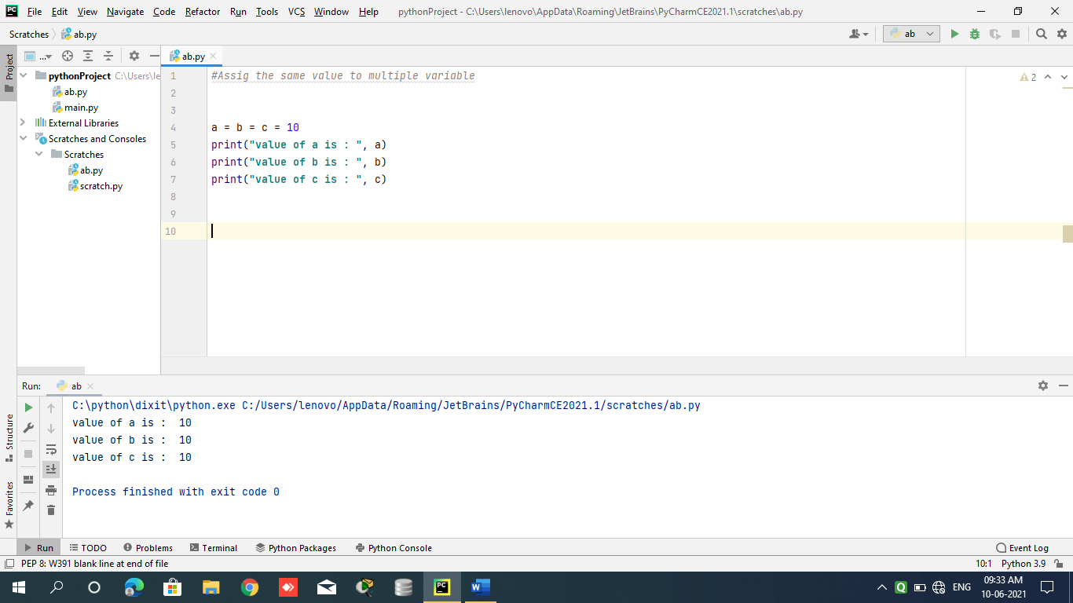

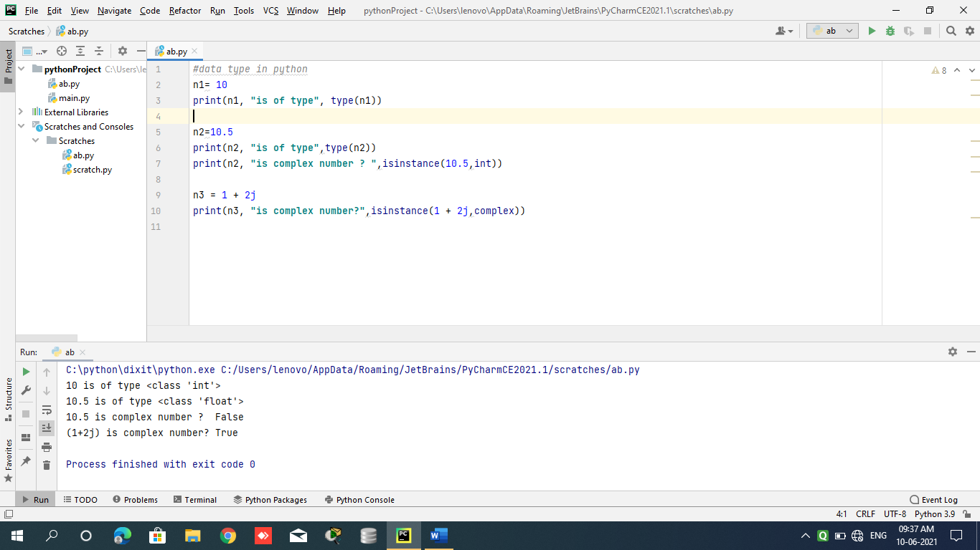

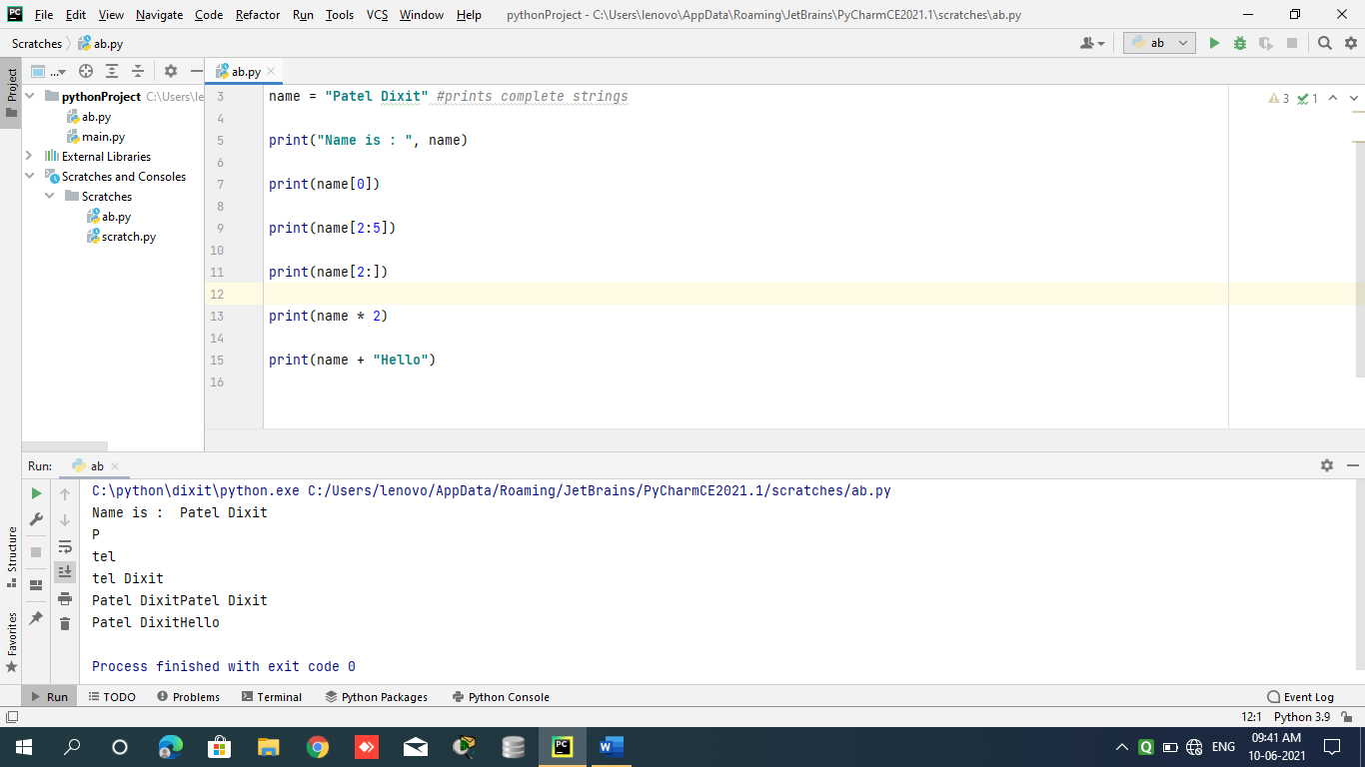

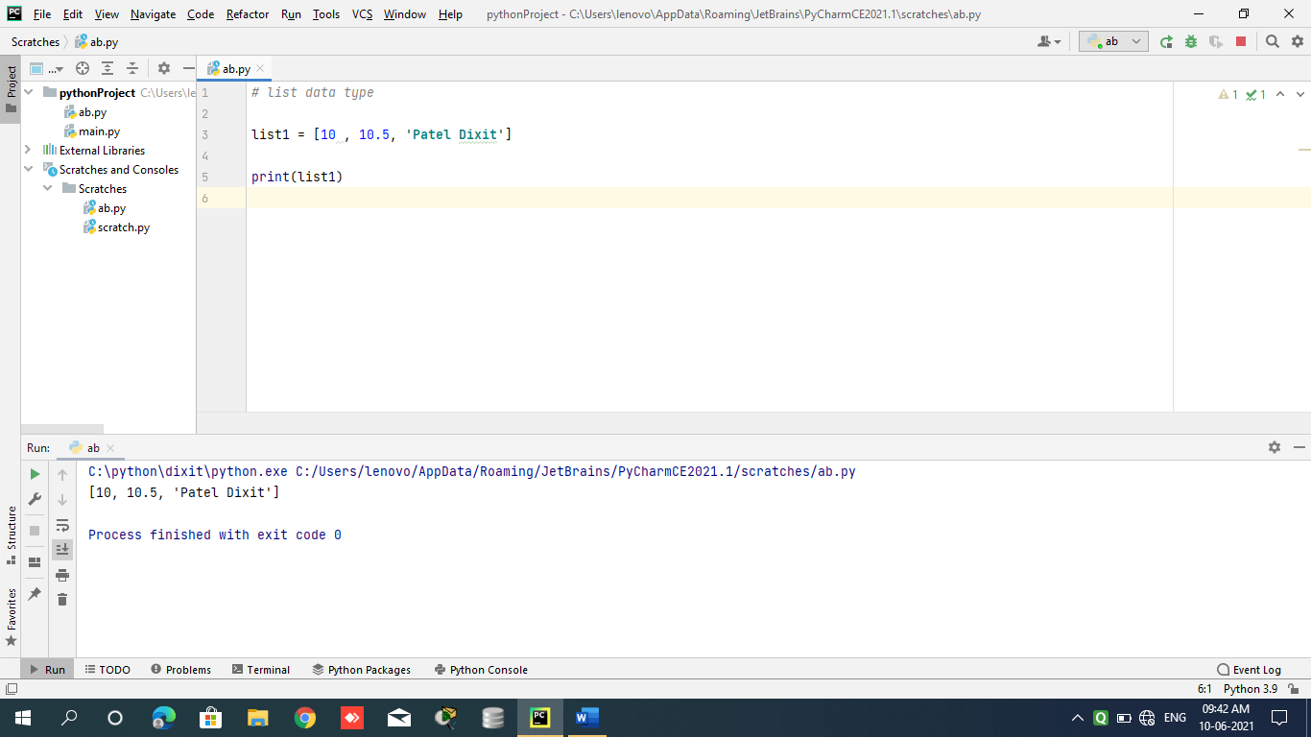

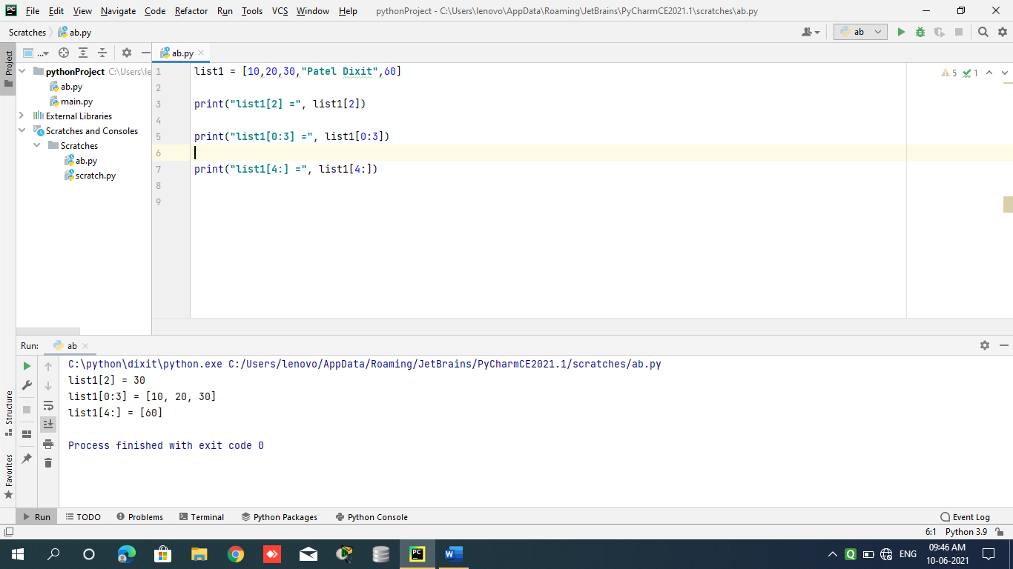

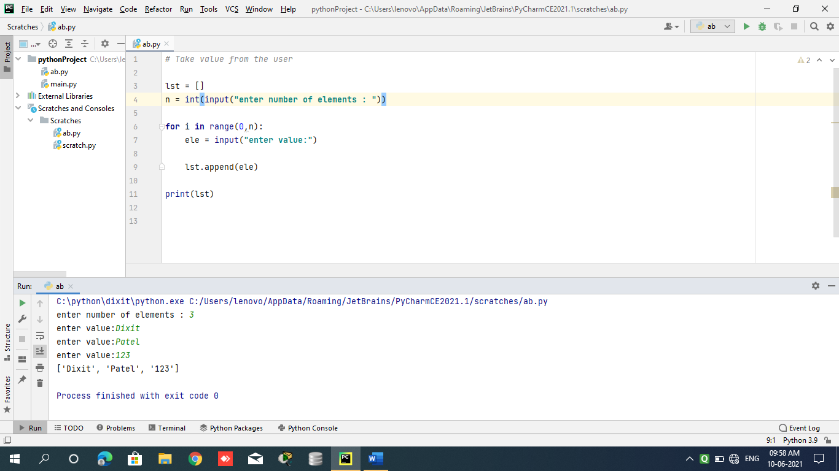

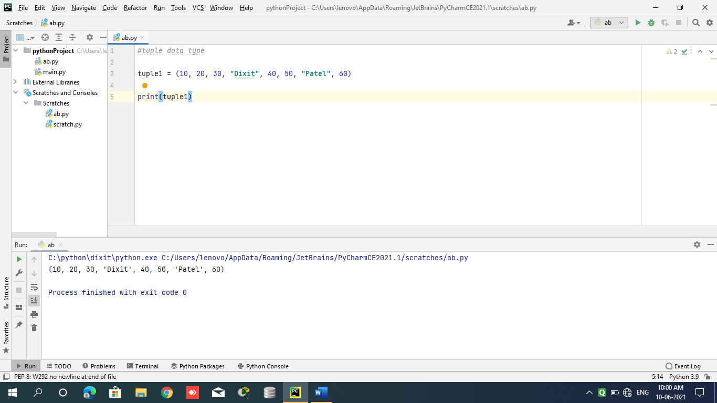

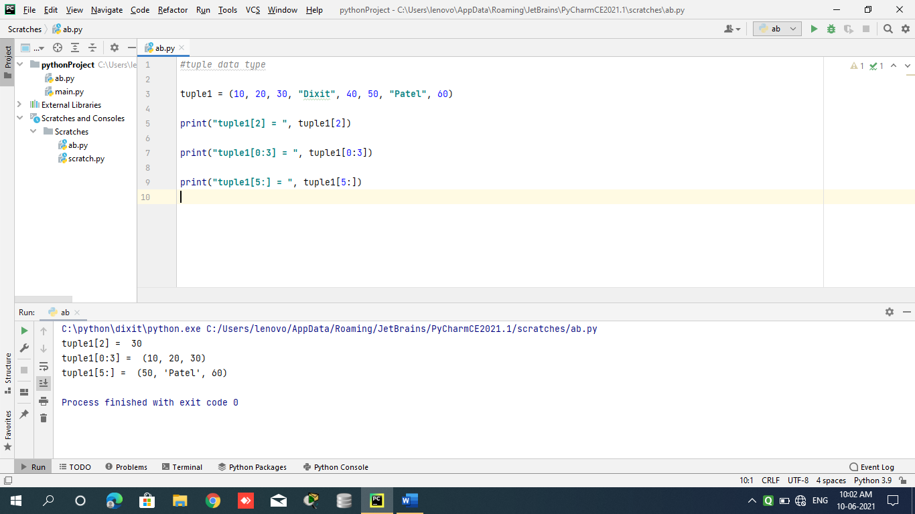

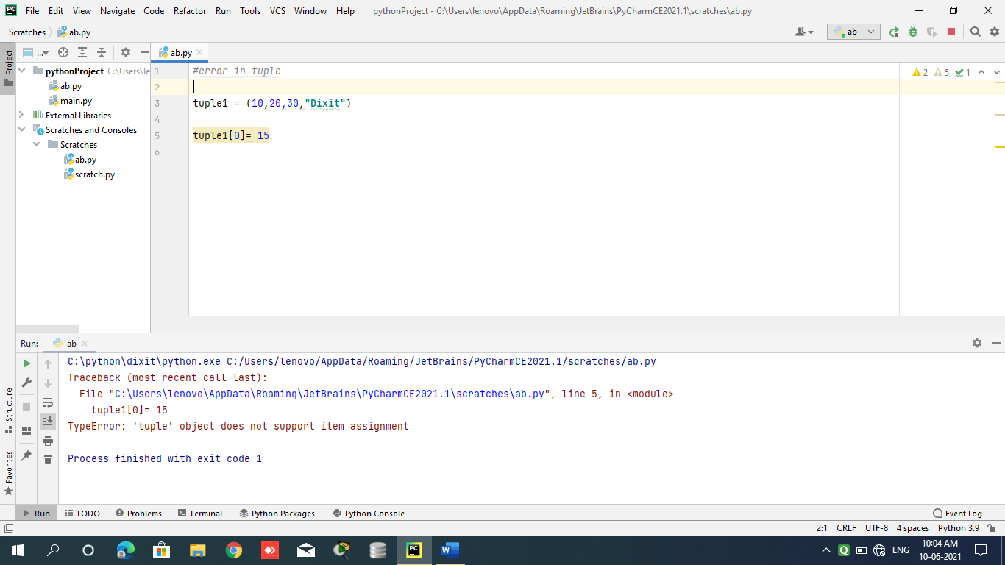

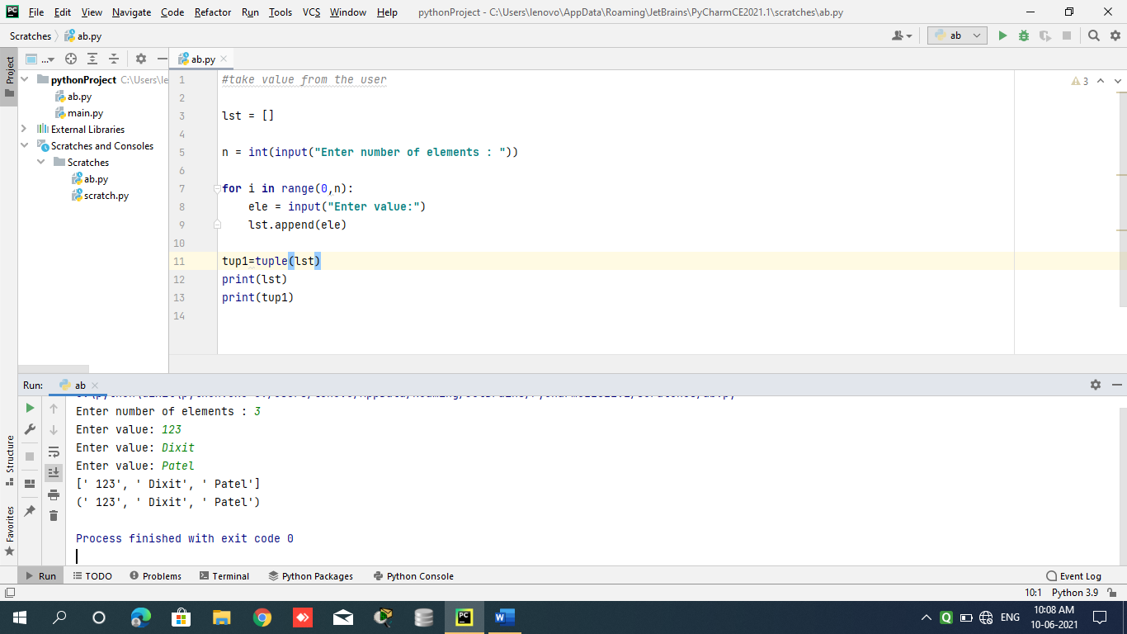

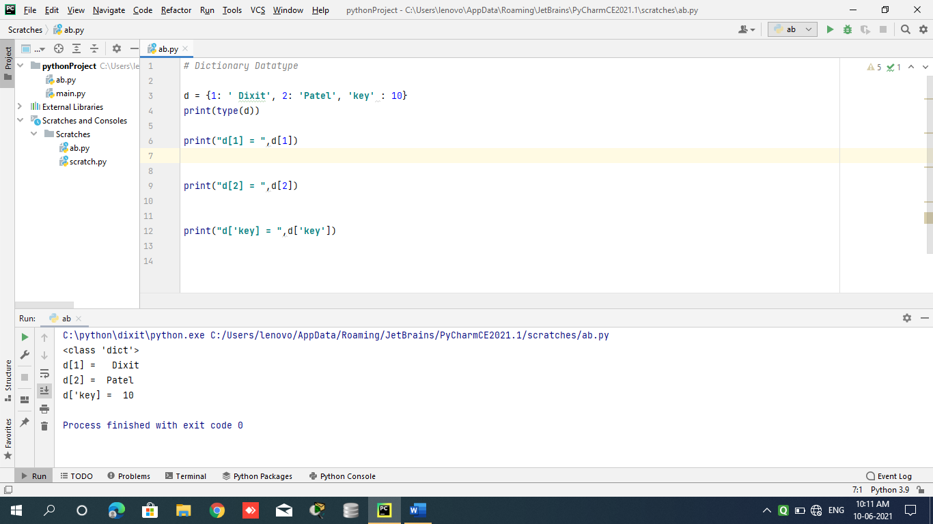

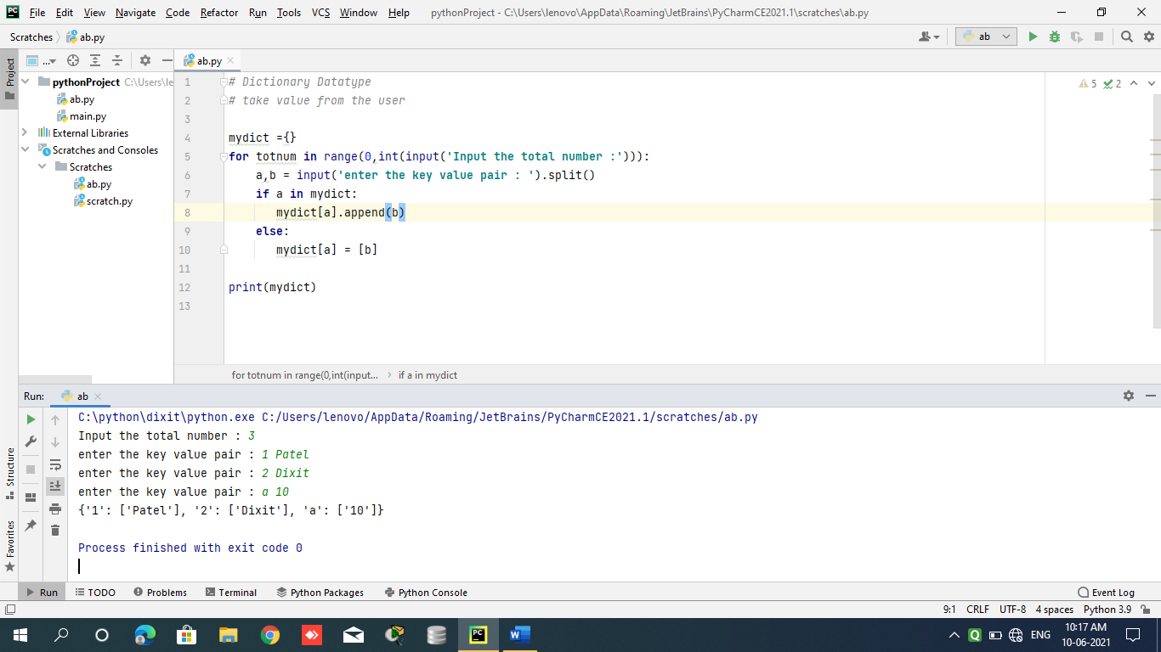

**Day 3**

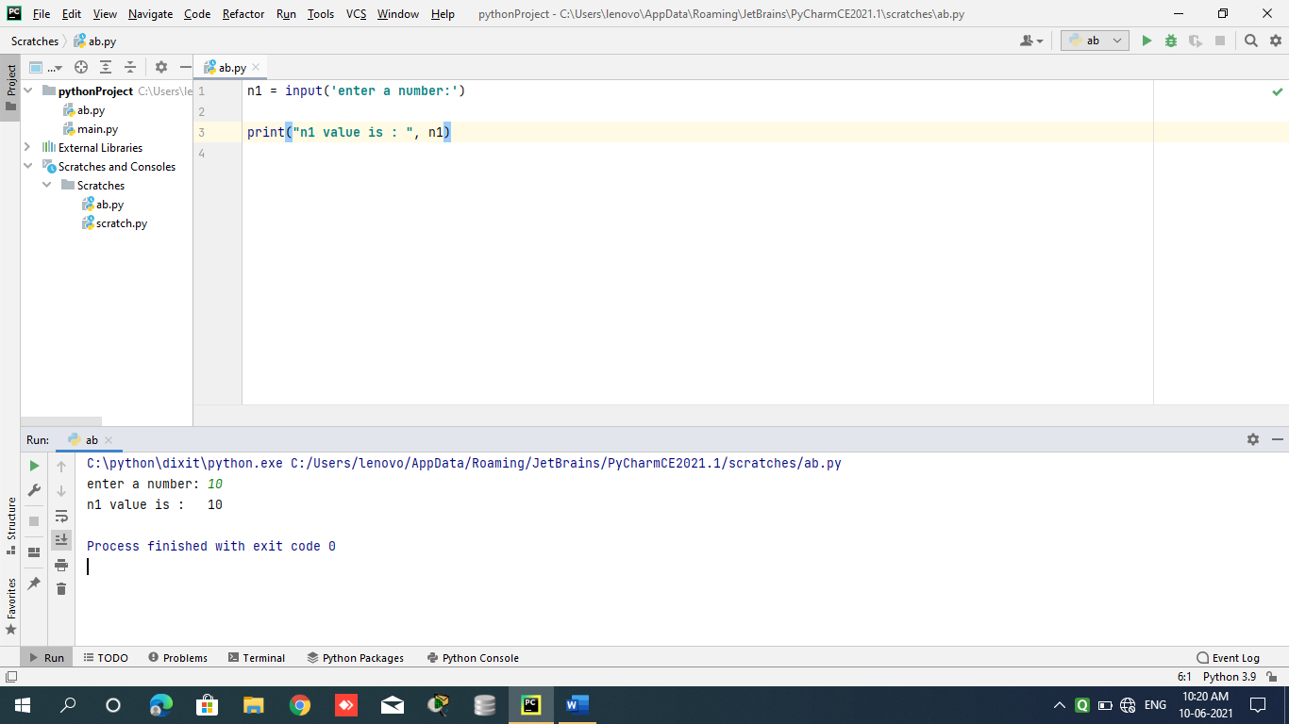

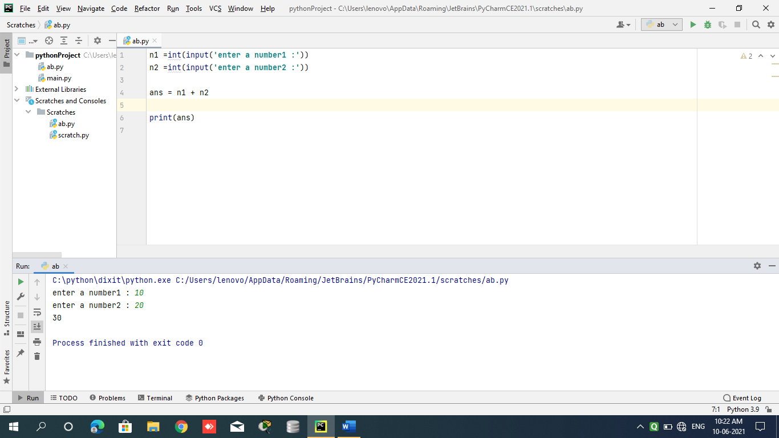

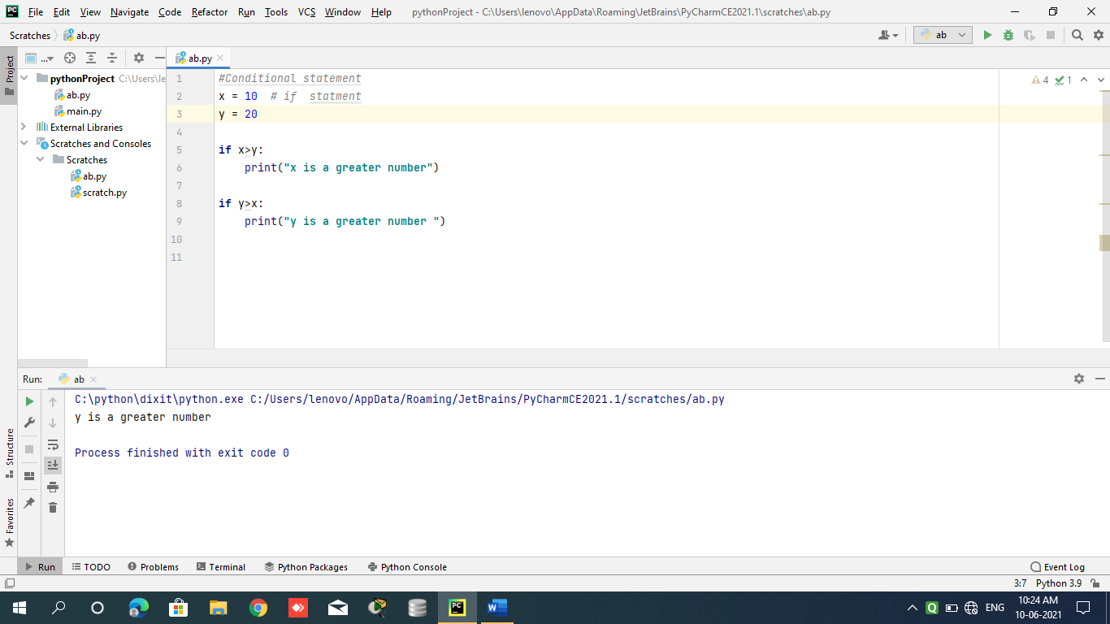

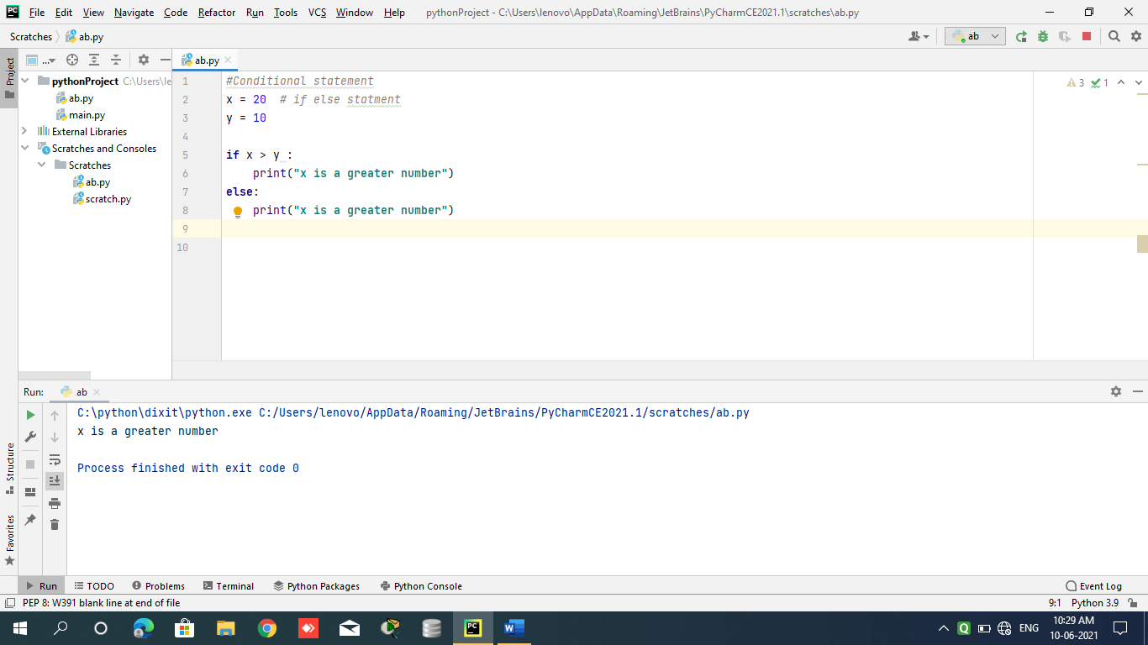

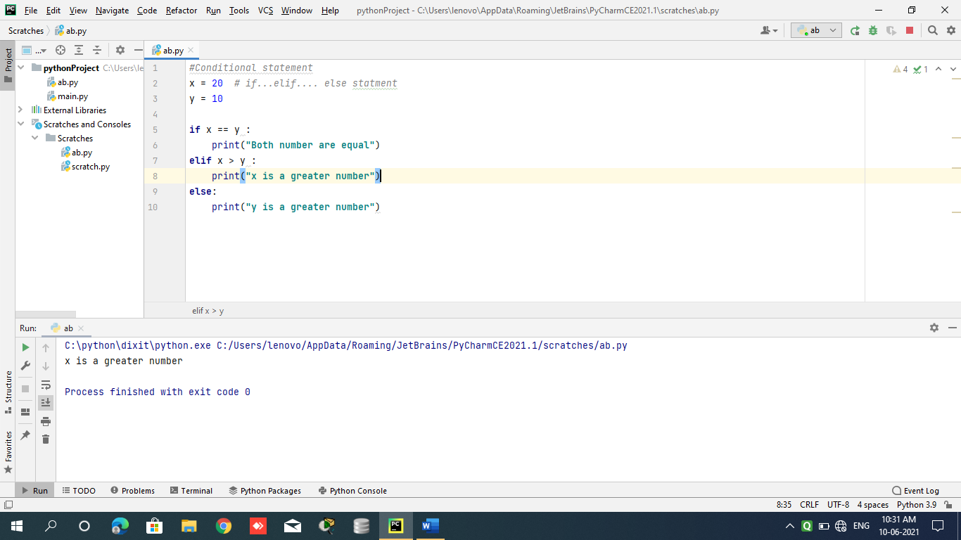

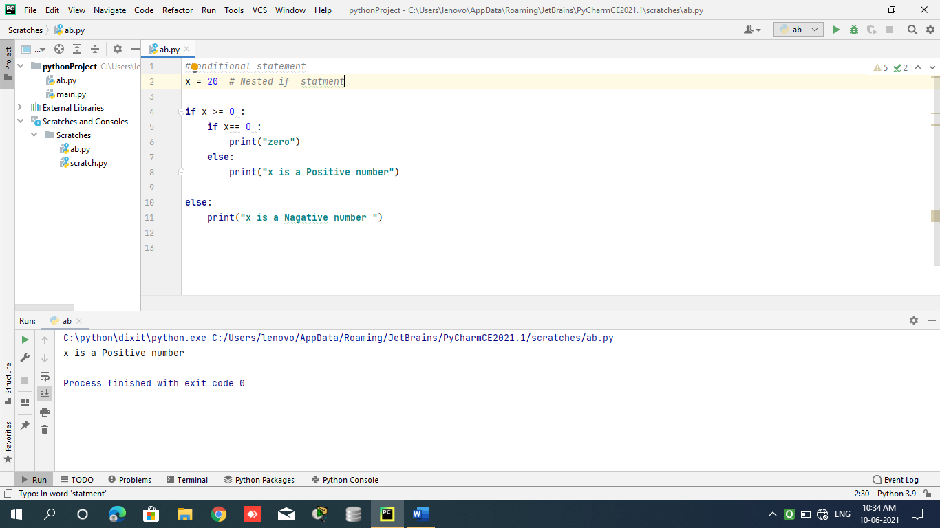

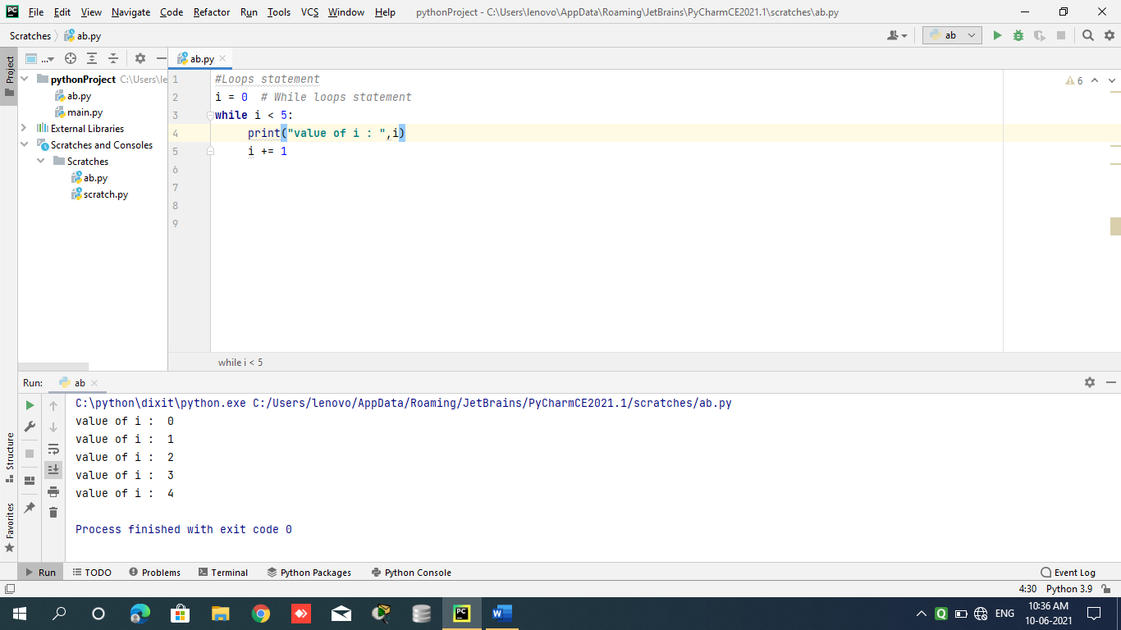

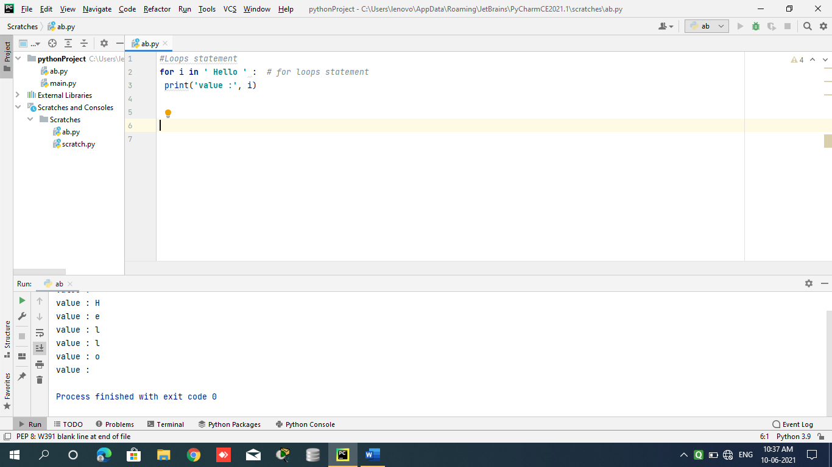

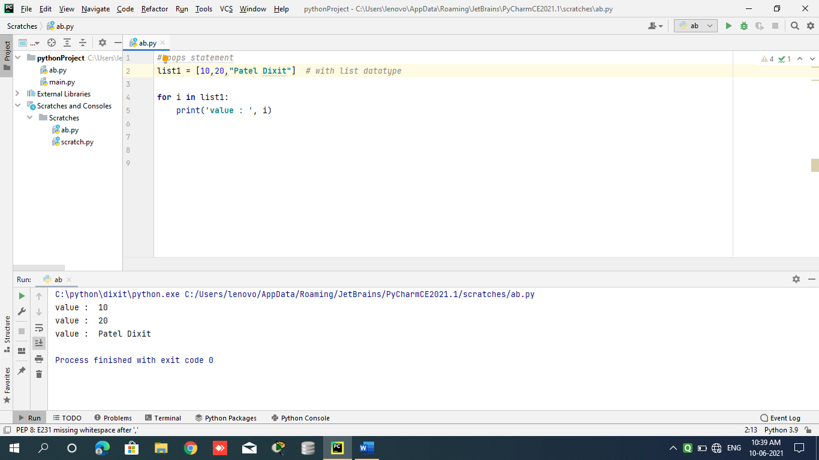

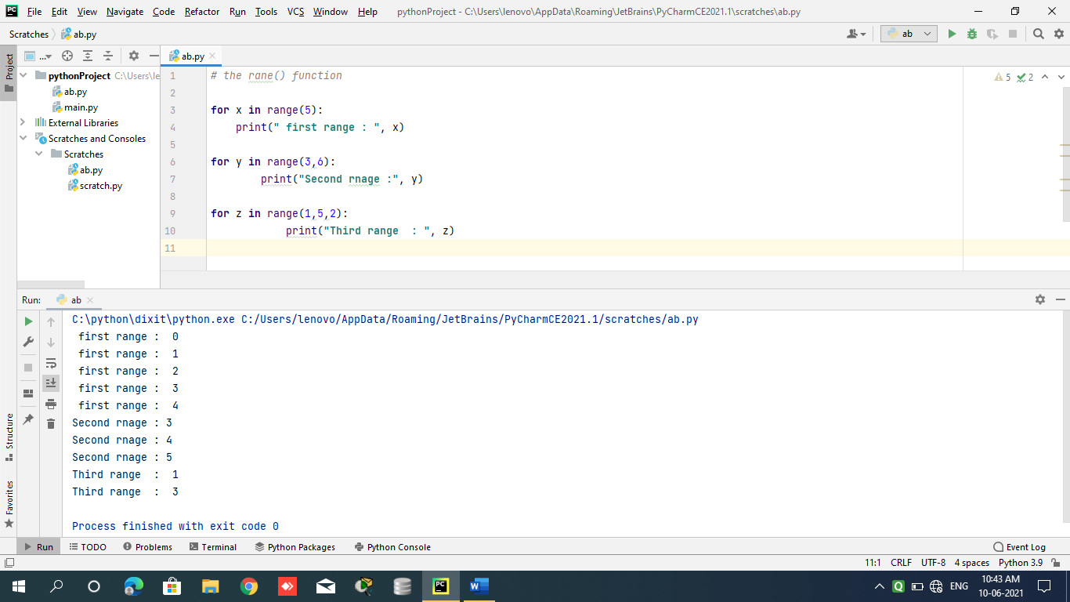

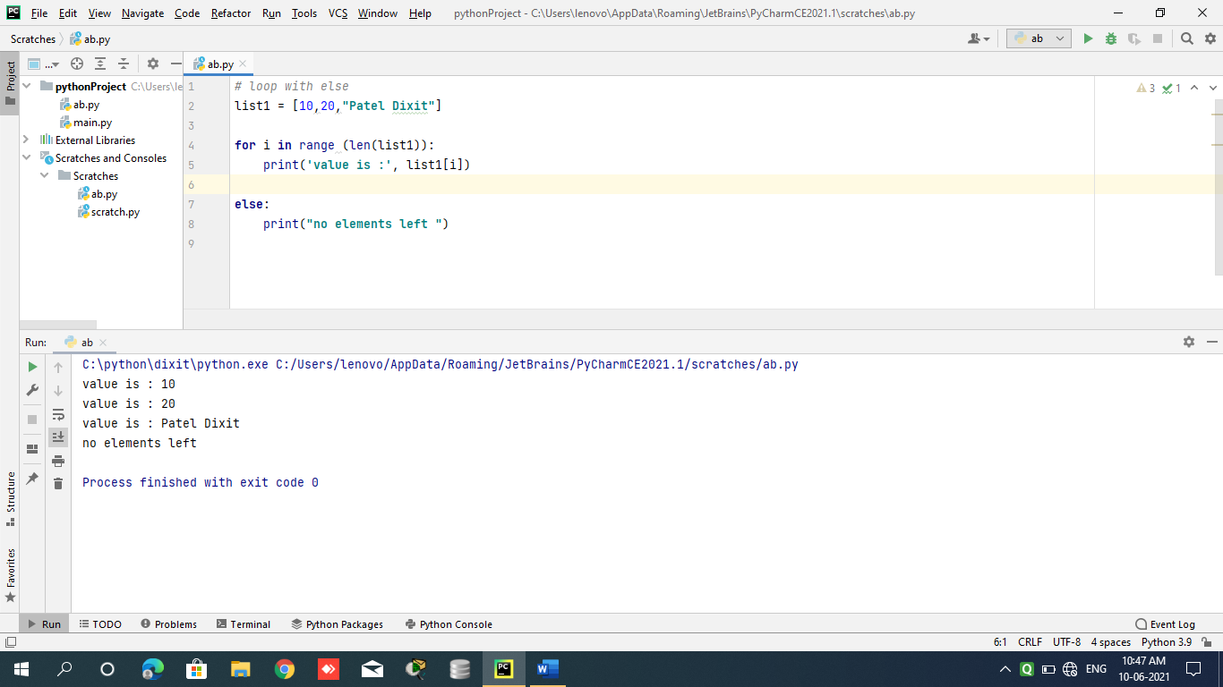

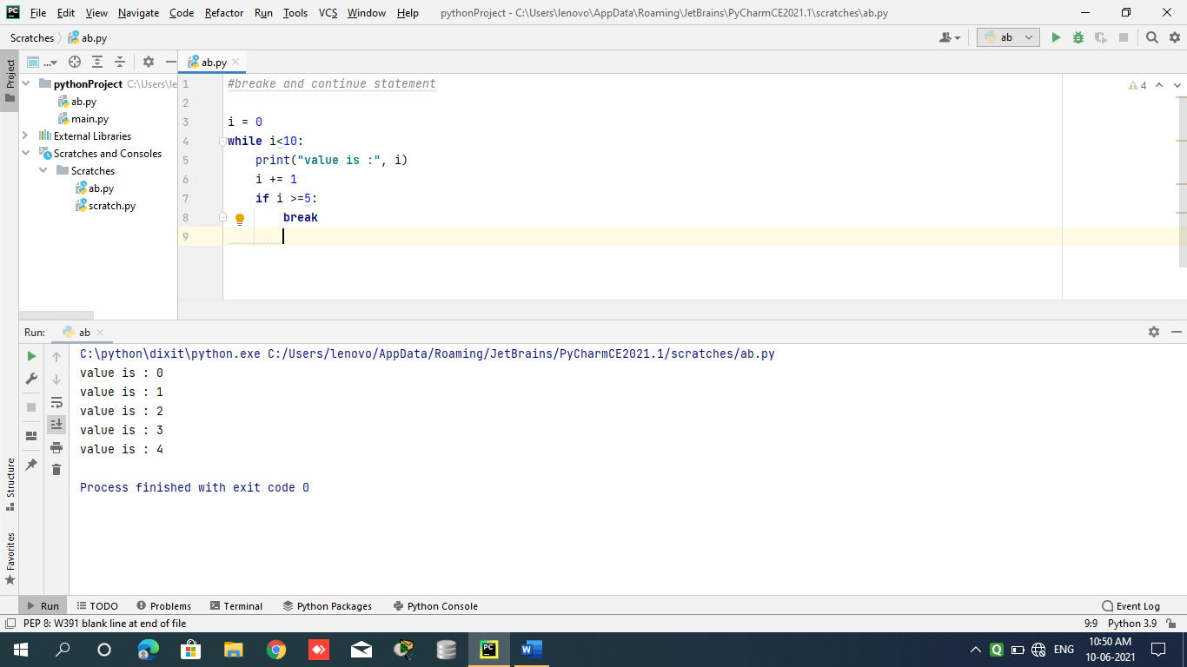

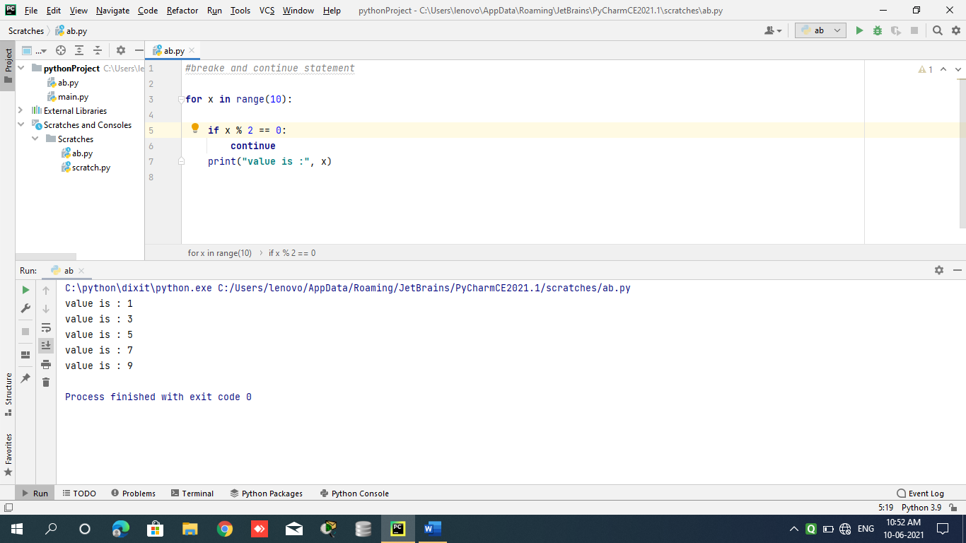

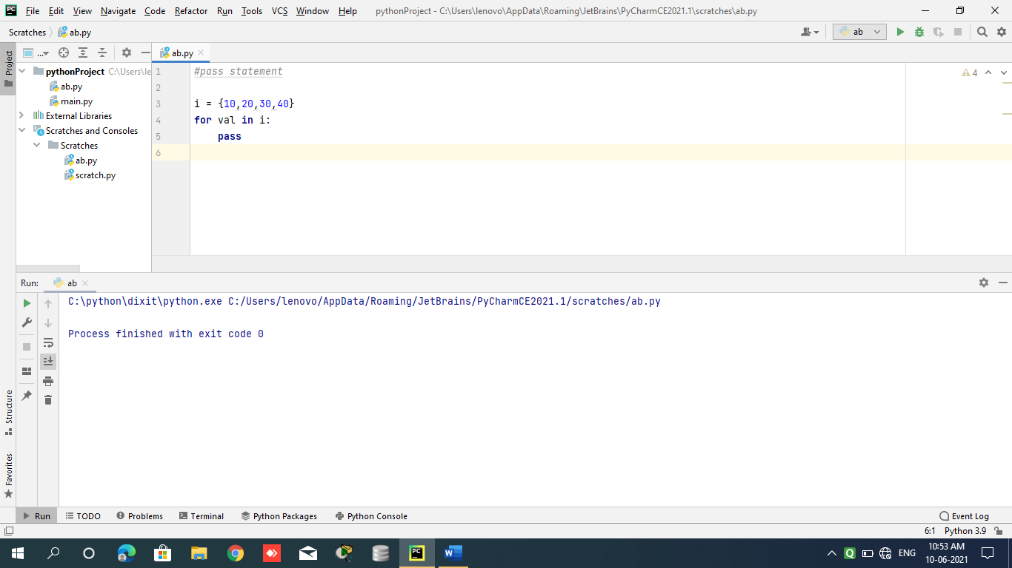

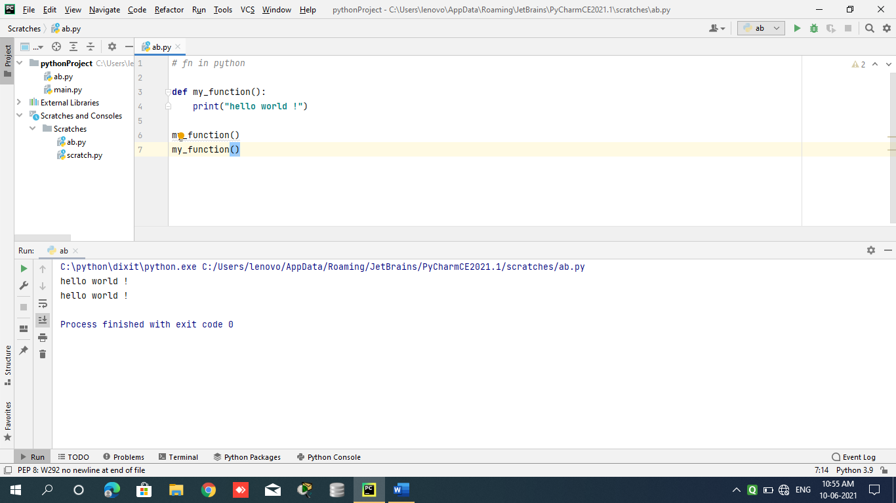

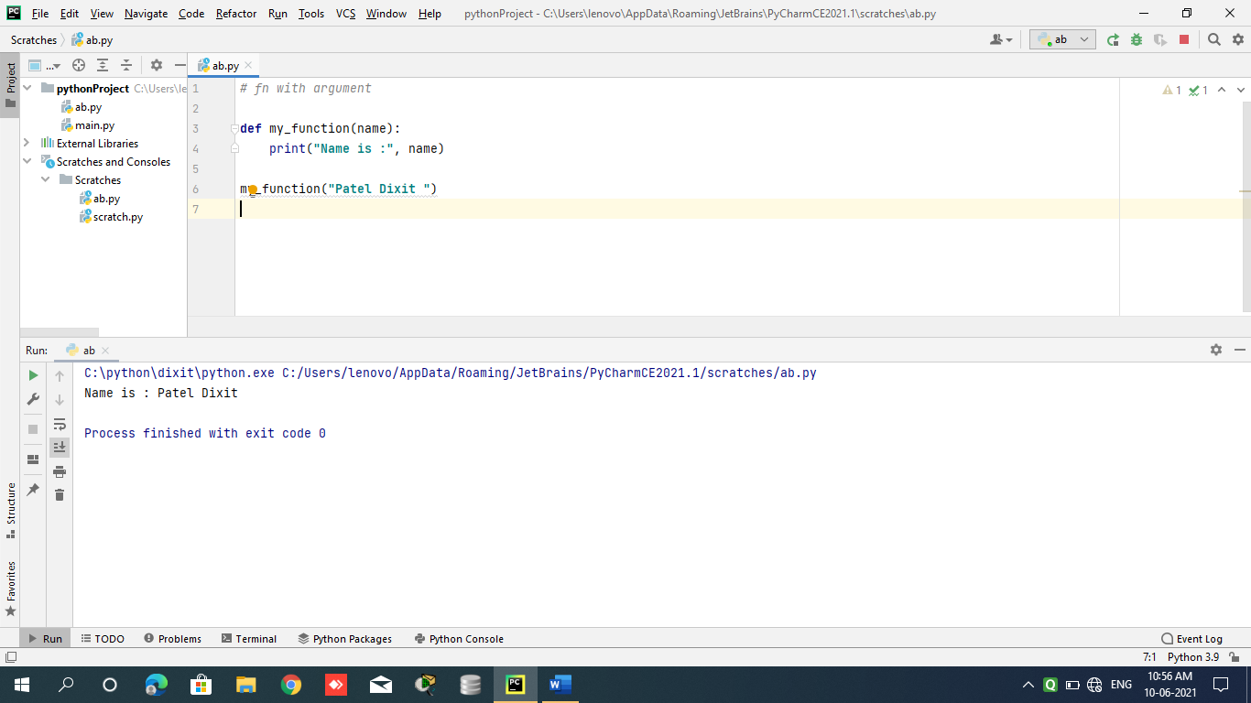

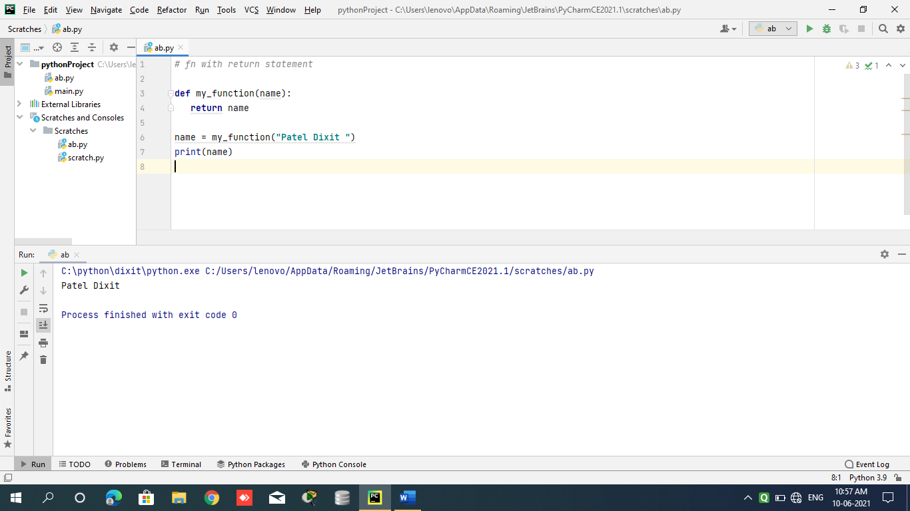

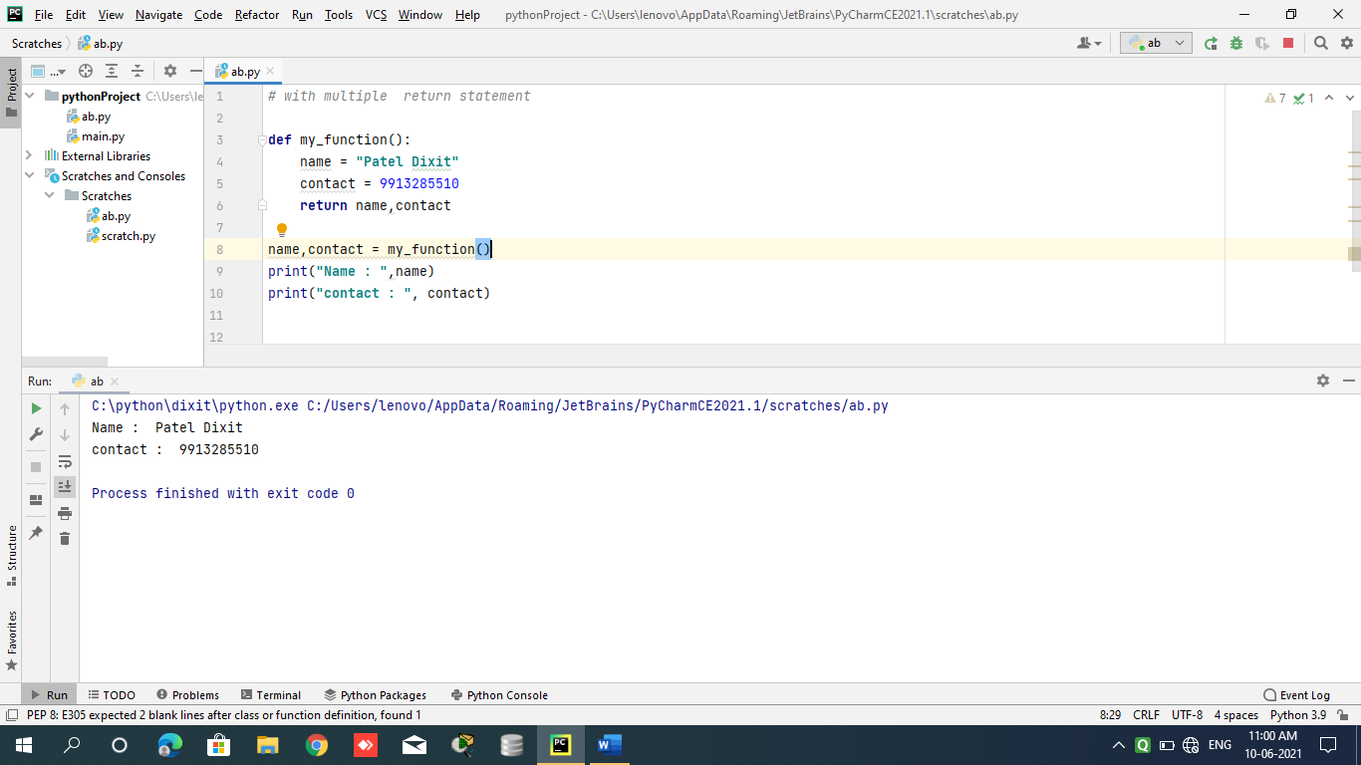

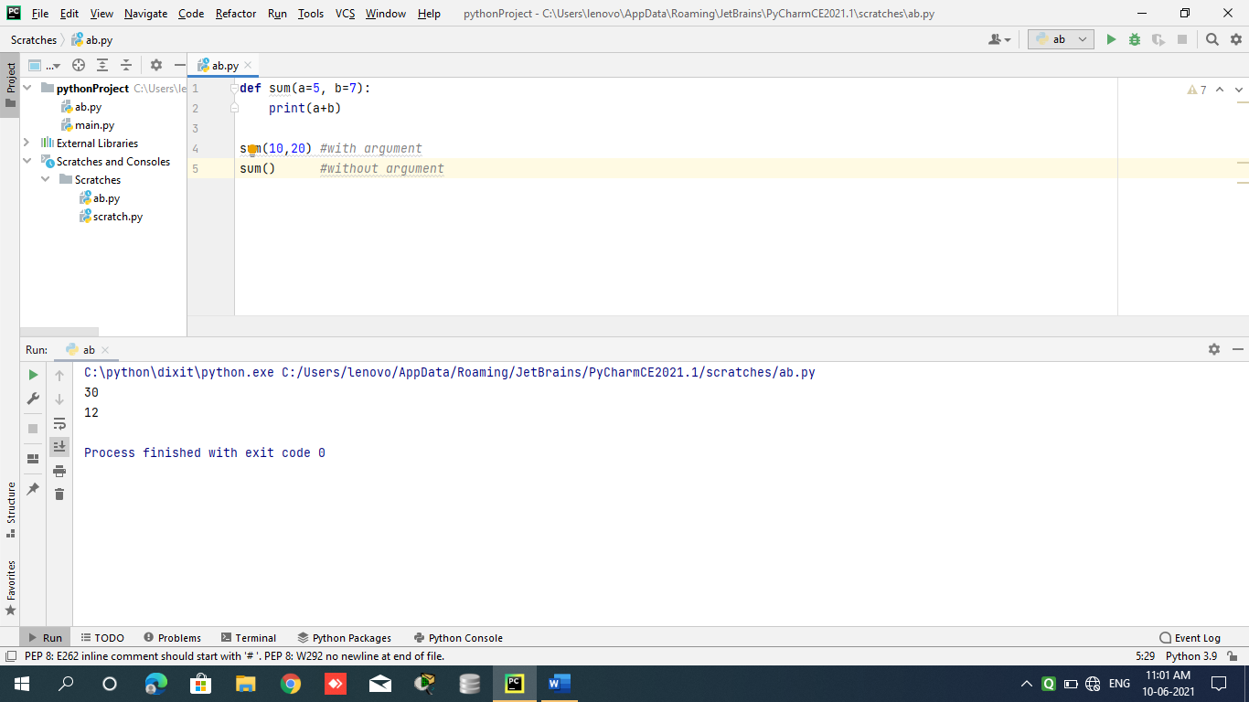

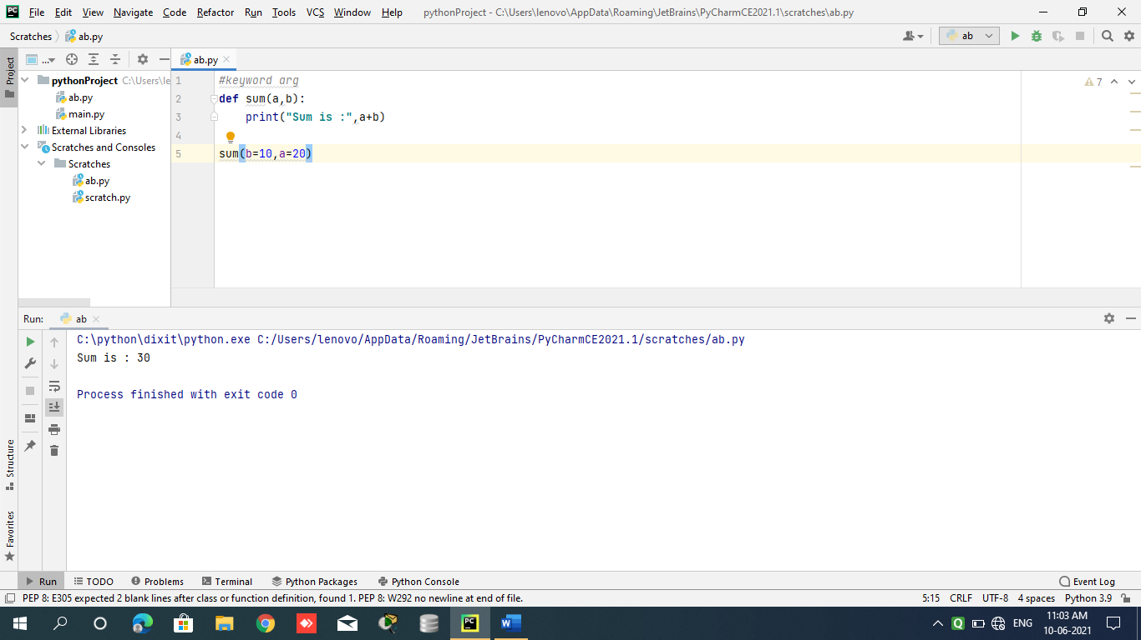

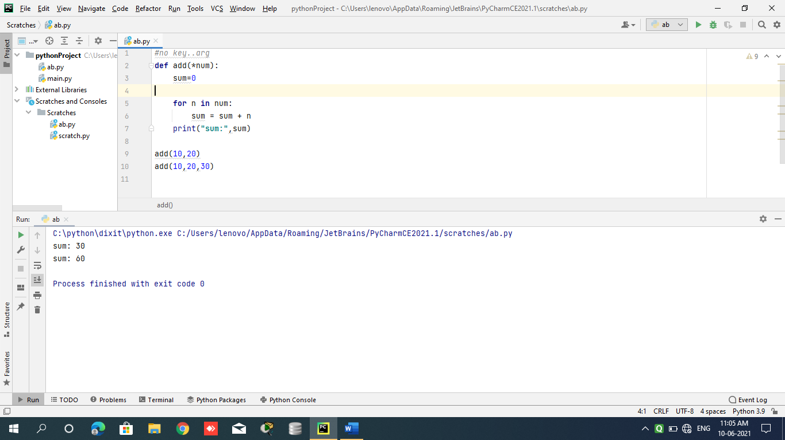

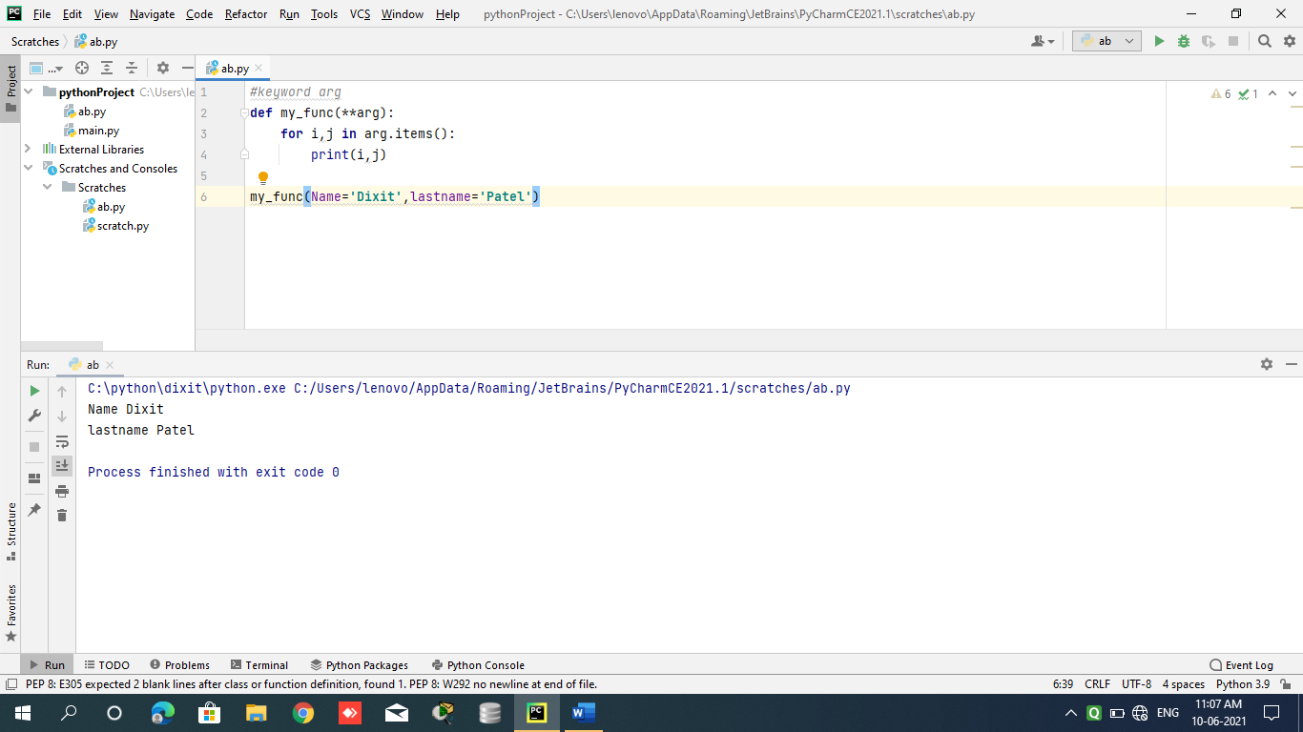

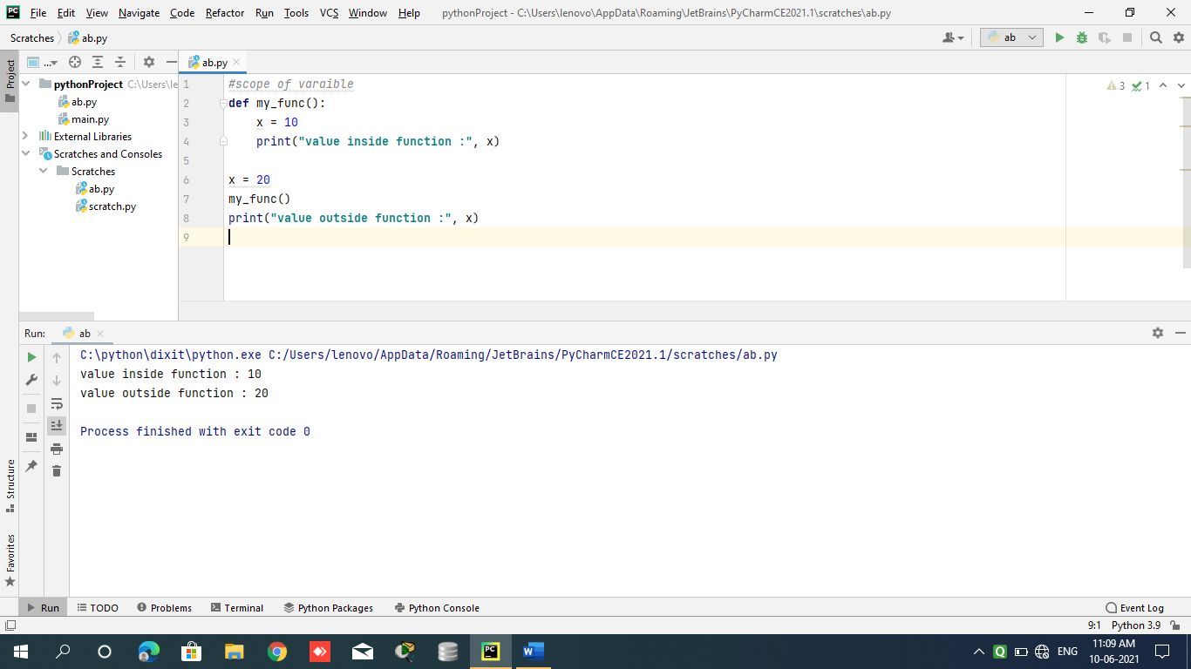

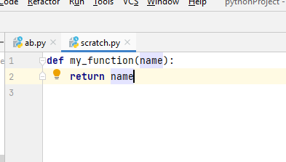

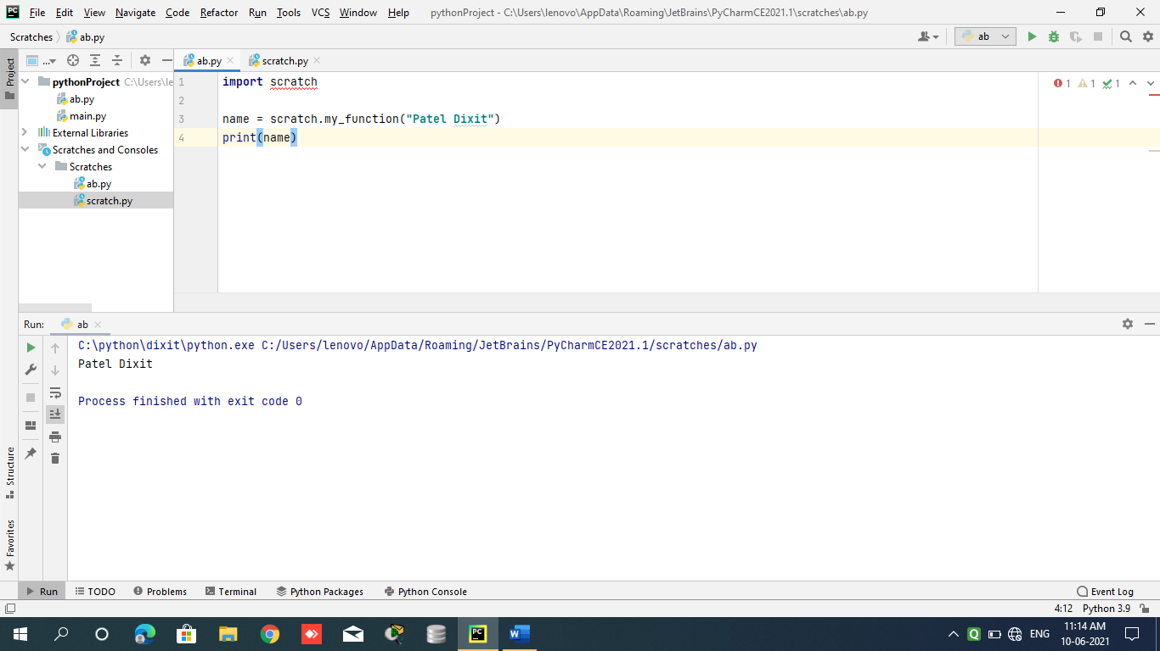

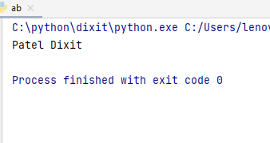

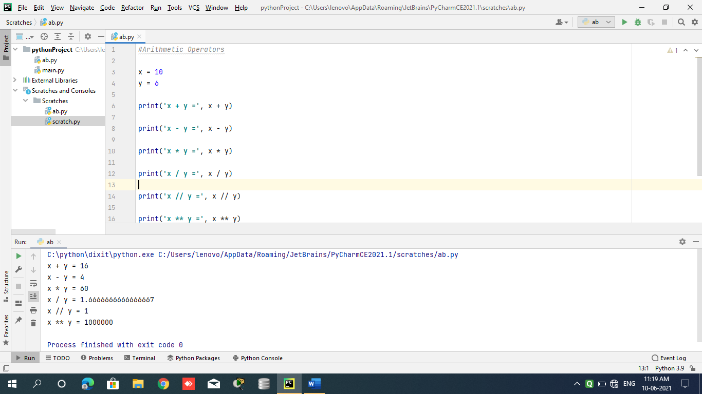

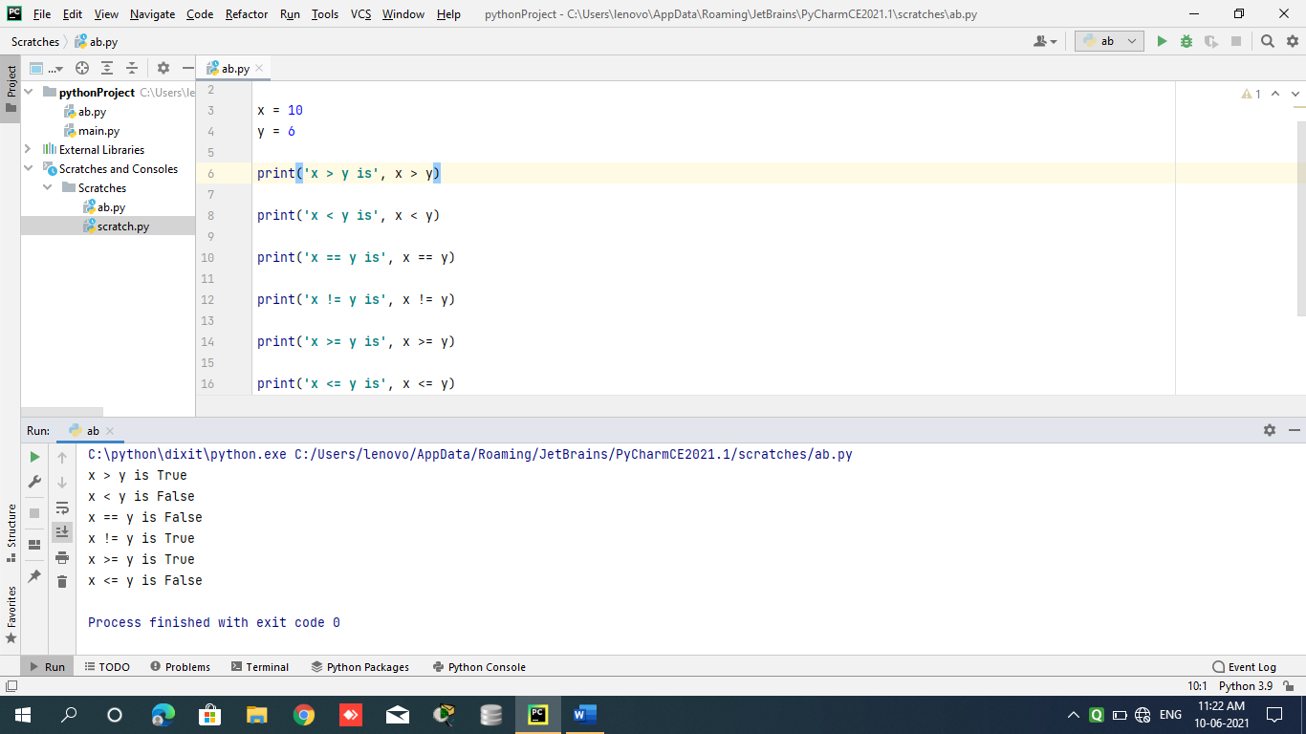

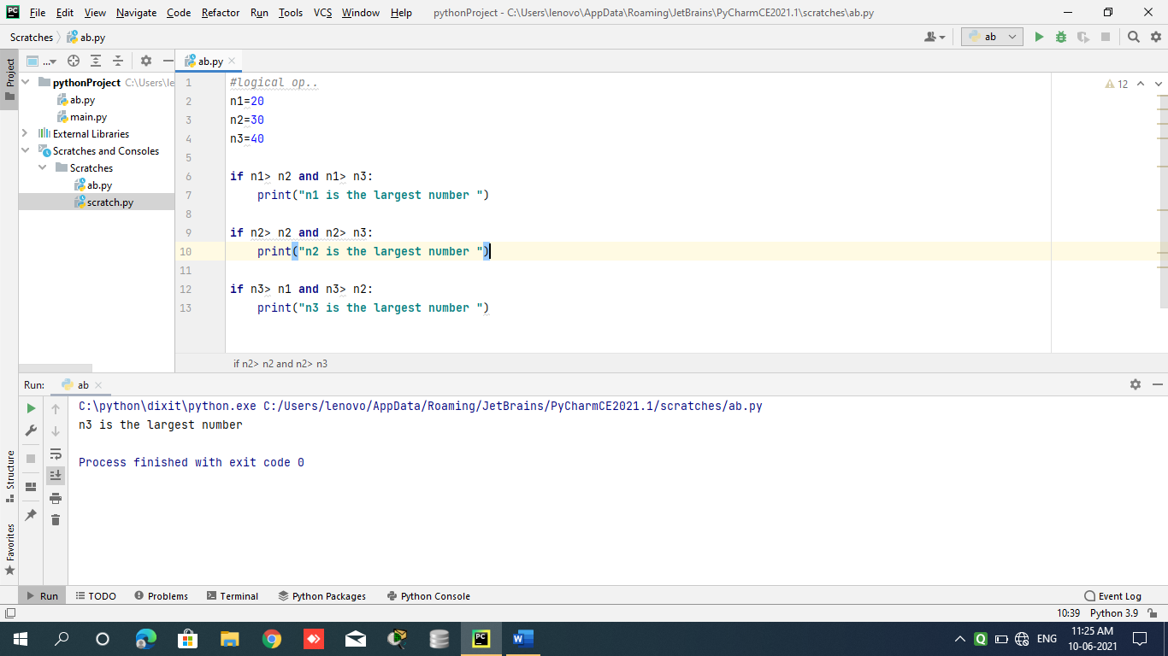

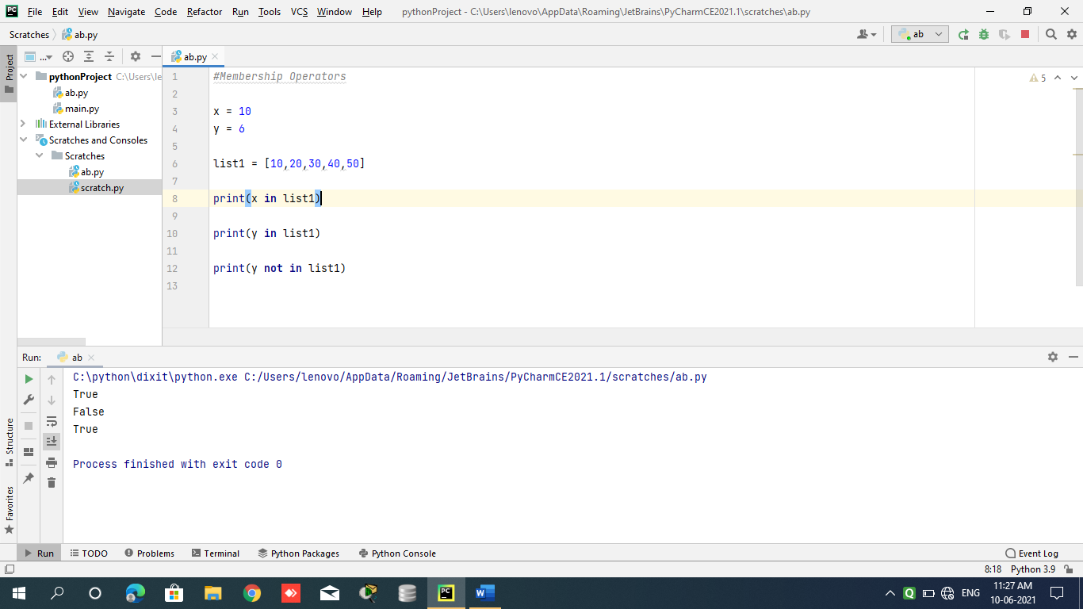

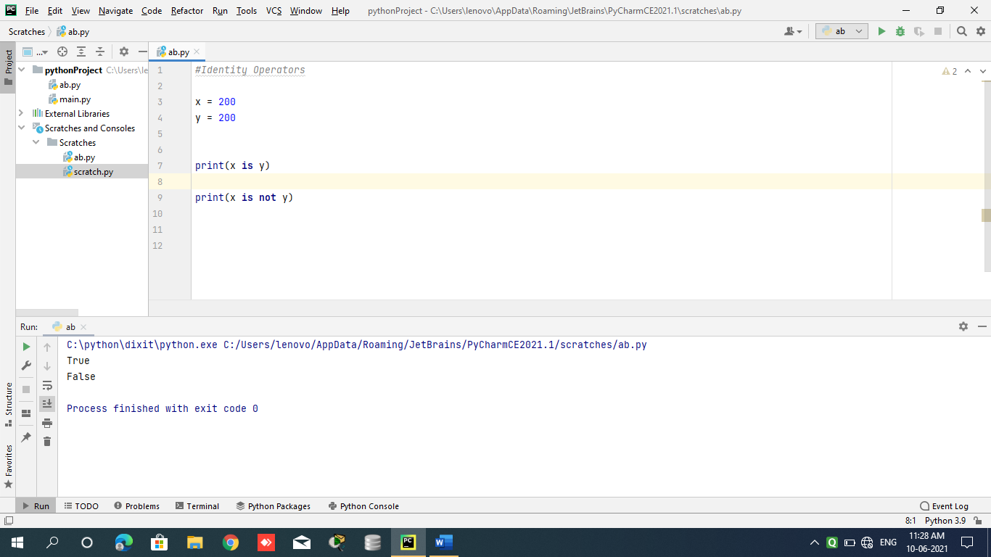

**Day 5**

* class test:  
   def myfunction(self): print(**"this is my function of class.."**)  
    
   def show(self,name): print(**"value is "**,name)  
    
  d1=test()  
  d1.myfunction()  
  d1.show(**"Dixit"**)

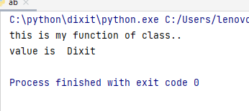

* **class** test:  
   **def** myfunction(self):  
   print(**"this is my function of class.."**)  
    
   **def** show(self,name):  
   print(**"value is "**,name)  
     
   **def** __init__(self): *#constructor* print(**"this is test class..."**)  
    
  d1=test()  
  d1.myfunction()  
  d1.show(**"Dixit"**)

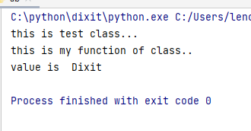

* **class** test:  
   **def** myfunction(self):  
   print(**"this is my function of class.."**
* **def** show(self,name):  
   print(**"value is "**,name)  
    
   **def** __init__(self,nm):  
   print(**"this is test class..."**)  
   print(**"name is"**,nm)  
    
  d1=test(**"abc"**)  
  d1.myfunction()  
  d1.show(**"Dixit"**)

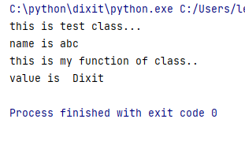

**Local to global assign value**

* **class** test:  
   name=**""  
    
   def** fun1(self):  
   print(**"this is normal method..."**)  
    
   **def** fun2(self,name):  
   self.name=name  
    
   **def** show(self):  
   print(**"name is "**,self.name)  
    
    
  d1=test()  
  d1.fun1()  
  d1.fun2(**"dixit"**)  
  d1.show()

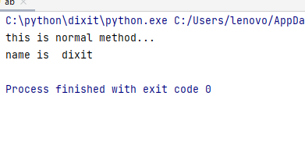

**Single level inheritance:**

* **class** test:  
   **def** __init__(self):  
   print(**"this is test class.."**)  
    
   **def** fun1(self):  
   print(**"this is parent class method.."**)  
    
  **class** test1(test):  
   **def** __init__(self):  
   print(**"this is test1 class.."**)  
    
   **def** fun2(self):  
   print(**"this is child class method.."**)  
    
  d1=test1()  
  d1.fun1()  
  d1.fun2()

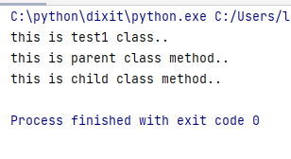

* **class** test:  
   **def** __init__(self):  
   print(**"this is test class.."**)  
    
   **def** fun1(self):  
   print(**"this is parent class method.."**) *#multi level inheritance***class** test1(test):  
   **def** __init__(self):  
   print(**"this is test1 class.."**)  
    
   **def** fun2(self):  
   print(**"this is child class method.."**)  
    
  **class** test2(test1):  
   **def** fun3(self):  
   print(**"this is child method of test2 class..."**)  
    
  d1=test2()  
  d1.fun1()  
  d1.fun2()  
  d1.fun3()

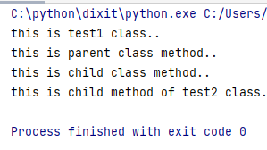

**Multiple inheritance:**

* **class** test:  
   **def** __init__(self):  
   print(**"this is test class.."**)  
    
   **def** fun1(self):  
   print(**"this is parent class method.."**) *#multi level inheritance***class** test1:  
   **def** __init__(self):  
   print(**"this is test1 class.."**)  
    
   **def** fun2(self):  
   print(**"this is child class method.."**)  
    
  **class** test2(test,test1):  
   **def** fun3(self):  
   print(**"this is child method of test2 class..."**)  
    
  d1=test2()  
  d1.fun1()  
  d1.fun2()  
  d1.fun3()

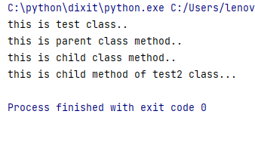

* **class** test:  
   **def** __init__(self):  
   print(**"this is test class.."**)  
    
   **def** fun1(self):  
   print(**"this is parent class method.."**) *#multi level inheritance***class** test1(test):  
   **def** __init__(self):  
   print(**"this is test1 class.."**)  
    
   **def** fun2(self):  
   print(**"this is child class method.."**)  
    
  **class** test2(test):  
   **def** fun3(self):  
   print(**"this is child method of test2 class..."**)  
    
  d1=test1()  
  d1.fun1()  
  d1.fun2()  
    
  d2=test2()  
  d2.fun1()  
  d2.fun3()

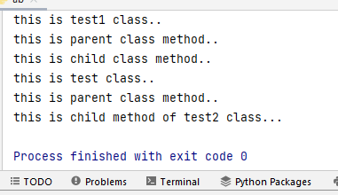

* **class** test:  
   **def** fun1(self):  
   print(**"this is test class.."**)  
    
  **class** test1(test):  
   **def** fun1(self):  
   print(**"this is test1 class.."**)  
    
    
  d1=test1()  
  d1.fun1()

